**Nov 2016 SL P1**

**Section A**

1. State **three** potential usability issues with cell phones. [3]

*Award up to* ***[3 max]****.*

Has a small (touch-sensitive) screen;

Uses batteries for power;

No hard disk drive / small memory;

Reliability / Network coverage issues;

Over in warm weather;

Too many steps to access a particular feature;

*etc*.

1. (a) State the purpose of cache memory. [1]  
     
     
     
   (b) Draw a diagram to show the relationship between random access memory (RAM),

Is used to save time in accessing RAM;

the processor and cache memory. [1]

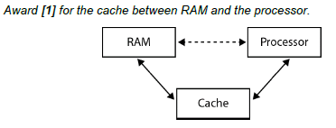

1. Outline **one** advantage and **one** disadvantage of wireless networks. [4]

*Award* ***[1]*** *for stating an advantage and* ***[1]*** *for an expansion.*

*Award* ***[1]*** *for stating a disadvantage and* ***[1]*** *for an expansion.*

Advantages and disadvantages such as:

• Ease of use for mobile users

• Connectivity between different locations

• Reliability

• Cost

• Security

• Change in working patterns

• Health issues

*etc*.

*Example answer:*

*Advantage*:

Ease of use for mobile users;

As they can work in many different locations;

*Disadvantage*:

Security issues;

As wireless transmissions are easily intercepted;

1. Construct a truth table for the Boolean expression not (A xor B) and C.

Use the following headings in your table.

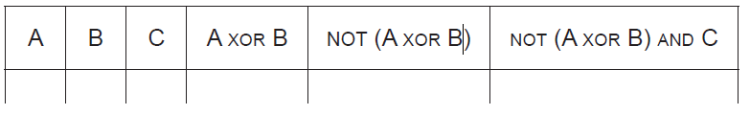 [4]

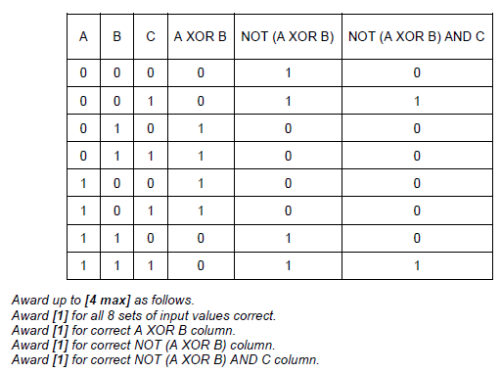

1. Many different people and organizations upload scientific materials to the internet.

A student uses data from the internet in a science project.

Outline **two** ethical issues concerning this use of the internet. [4]

*Award* ***[1]*** *for an ethical issue,* ***[1]*** *for an explanation, for two issues up to* ***[4 max]****.*

*Points to be discussed:*

The data/information is deliberately incorrect;

The data/information has not been validated;

Intellectual property issues;

Plagiarism;

1. Consider the following algorithm that inputs X and N, and outputs P.

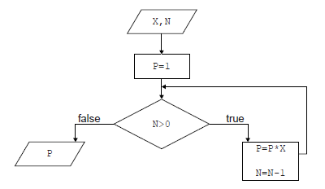

1. Determine how many times multiplication is performed when this algorithm is executed. [1]

N;

1. Construct a trace table for the algorithm when X=2 and N=4. Use the following

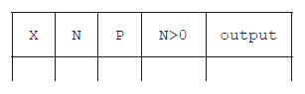headings in your table.   
  
  
  
  
  
 [4]

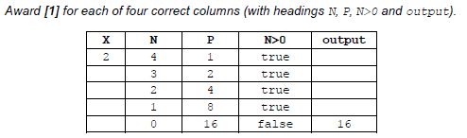

1. State the purpose of this algorithm. [1]

Calculates XN;

***Note:*** *DO NOT accept vague answers that may suggest the understanding of* NX *or use*

*incorrect terminology*

1. Outline the features of a virtual private network (VPN).

*Award up to* ***[2 max]****.*

VPN transmission is always encrypted / provides a secure connection;

Establishes the tunnel between sender/receiver;

Sender/receiver is authenticated before sending/receiving;

VPN users have access to all services available;

**Section B**

1. A book shop has a computer at each point of sale, and also a central computer.

When a customer buys a book in the book shop, the salesperson at the point of sale uses a

scanning device to input a barcode from the book.

The barcode is sent to the central computer where the barcode of each book and the

corresponding price are held in a database on a disk.

When the price is found, it is sent to the point of sale computer where all necessary

calculations are performed, details of the transaction are stored on a local disk and a receipt

is printed out.

1. Construct a system flow chart for the system described above. [5]

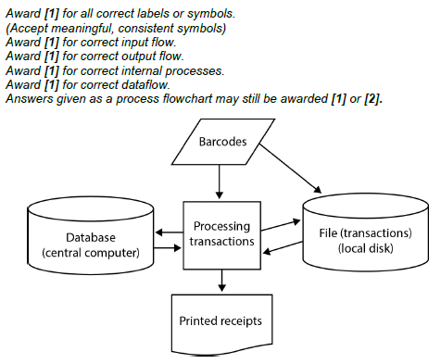

At the point of sale there are peripheral devices other than the scanning device and printer.

1. Outline the purpose of **one** other possible peripheral device in this scenario. [2]

*Award* ***[1]*** *for identifying a peripheral device,* ***[1]*** *for stating its purpose.*

*Example answers:*

Keyboard;

To type in some additional data;

Or to type in barcode data when it is not possible to scan;

Magnetic card reader;

Used when a credit card is used;

Microphone;

To call the next customer;

To call manager;

Monitor;

So the salesman can see the information/data on the screen;

Visual display;

So the customer can read the information/data on the display;

Speakers;

For customers to hear information;

For shop assistants to bring another item the customer may wish to buy;

The customers can also buy books online. A customer can select a book, and then enter  
 their name, address and credit card number. This data is stored on the book shop’s  
 central computer in a database of customer orders.

1. Outline the purpose of protocols in transferring this data. [2]

*Award up to* ***[2 max]****.*

Protocols are sets of rules for transmitting data correctly;

They ensure that data is sent from a customer's computer and received by theshop’s computer;

To create a secure transmission of data from the client to the server through the useof the Hypertext Transfer Protocol (HTTPS) *ie* the customer can pay for the bookssecurely (using TLS or SSL).

1. (i) Identify **two** sources of risk to personal data in this online system. [2]

Data can be at risk whilst stored on the shop’s disk;

Data can be at risk during transmission;

(ii) State **two** measures that the book shop can take to address the risks identified

in part (d)(i). [2]

*Award up to* ***[2 max]****.*

All private information must be encrypted;

Transmission channel must be protected by encryption;

Logging on to the system must be secured (to prevent intruders);

Dual data back-up system in case of accidental deletion;

(iii) Outline the consequences to the customer if their data is not adequately protected. [2]

*Award up to* ***[2 max]****.*

Details stolen;

Used for fraudulent purposes;

Contact details could be shared;

Used for junk mail/fraud;

Personal details stolen;

For identity theft;

1. A new higher level programming language is being developed.
2. Identify **two** reasons why consistent grammar and syntax should be essential features

of a higher level programming language. [2]

*Award up to* ***[2 max]****.*

Easy to learn/use;

Otherwise time may be wasted learning the new language/writing programs in

this HLL;

There will be no/less compilation errors;

There will be no/less logical errors;

(Reduction of time to create software;)

Future maintenance/development is possible by other programmers;

1. Identify **two** features of a user interface that will allow application programmers to

interact more easily with the programming language. [2]

*Award up to* ***[2 max]****.*

GUI;

Toolbars;

Menus;

Built in commands for inputting from touch screens;

Predicted text so that typing a class name followed by a full stop will bring up a listof methods/attributes;

Automatically use a colour to represent keywords/variables and improve readability

1. State one method of providing user documentation. [1]

*Award* ***[1 max]****.*

Help files;

Online support;

Application programmers who use this programming language will be able to choose to use  
 either an interpreter or a compiler.

1. (i) Outline the need for an interpreter or a compiler. [2]

*Award up to* ***[2 max]****.*

Must be translated from a higher level language understandable by humans/not understood by machines;

Must be translated into machine code;

For the CPU to execute it;

(ii) Describe one advantage to application programmers of having both an

interpreter and a compiler available. [2]

*Award up to* ***[2 max]****.*

Interpreter is faster/immediately warns about syntax errors/executes commands and they could use it instead of the compiler while coding and debugging their programs;

Compiler is required when there is a need to produce an executable version of a program;

One of the predefined sub-programs in the new language is sumOdd(). It accepts an integer  
 N as input. If N<=0 it outputs -1, otherwise it outputs the sum of the first N odd numbers.

For example:

sumOdd(4) outputs 16, because 4 is not less than 0, and 1 + 3 + 5 + 7 = 16.

sumOdd(−3) outputs −1, because −3 is less than 0.

1. Construct, in pseudocode, the algorithm for sumOdd(). [4]

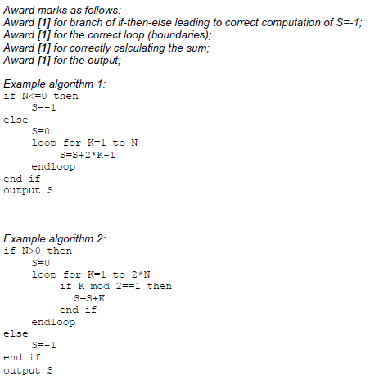

1. Outline the need for predefined sub-programs and collections. [2]

*Award* ***[1]*** *for any of the benefits listed below,* ***[1]*** *for an expansion*

*(ie when/why/who will need it?).*

Reusability;

Modularity;

Reliability / All predefined sub-programs are tested and reliable;

*etc*.

*Example answer:*

Predefined sub-programs and collections are reusable;

And this reduces the cost/time needed to develop a large program;

1. In a school there are 2400 students and each student uses one locker. Each locker has a unique

number from 1 to 2400.

The lockers are to be painted in four colours: red, white, yellow and blue, in order of locker

numbers, as shown in the following table.

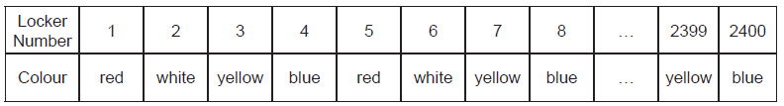

The pattern of colours continues in this manner. For example, locker number 15 will be  
painted yellow.

1. State the colour that locker number 442 will be painted.

White;

Each student is responsible for painting his or her locker. Some students do not know how  
to determine the colour they should use.

1. Construct, in pseudocode, an algorithm that accepts a locker number as input,

and outputs the colour that this locker should be painted.

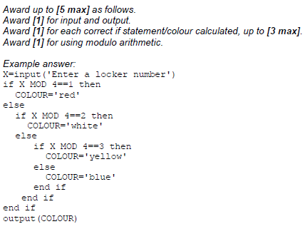

Three arrays are used to hold the following information:

• the names of students in alphabetical order, are held in the array STUDENT_NAME[];

• the corresponding locker number is held in the array LOCKER_NO[];

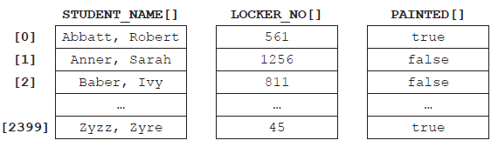• whether the locker has been painted or not is held in the array PAINTED[].

For example STUDENT_NAME[1] is Sarah Anner. She is responsible for locker number 1256  
and this locker has not been painted yet.

1. (i) State the name of the student who is responsible for painting locker number 811. [1]  
     
     
     
   (ii) Construct, in pseudocode, an algorithm that counts and outputs the number of  
    lockers that have been painted so far. [4]

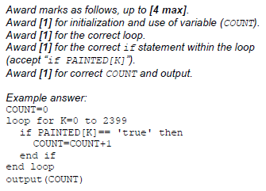

Baber, Ivy;

1. Describe an efficient algorithm, which accepts a student’s name as input, and outputs

the corresponding locker number and whether or not it has been painted. [4]

*Award* ***[1]*** *for stating that the position of a given name should be found in arraySTUDENT_NAME[].*

*Award* ***[1]*** *for using this position to access the elements in the other*

*two arrays.*

*Award* ***[1]*** *for any named searching algorithm (linear or binary search).*

*Award* ***[1]*** *for explaining the efficiency – binary search used becauseSTUDENT_NAME[] is sorted in alphabetical order.*